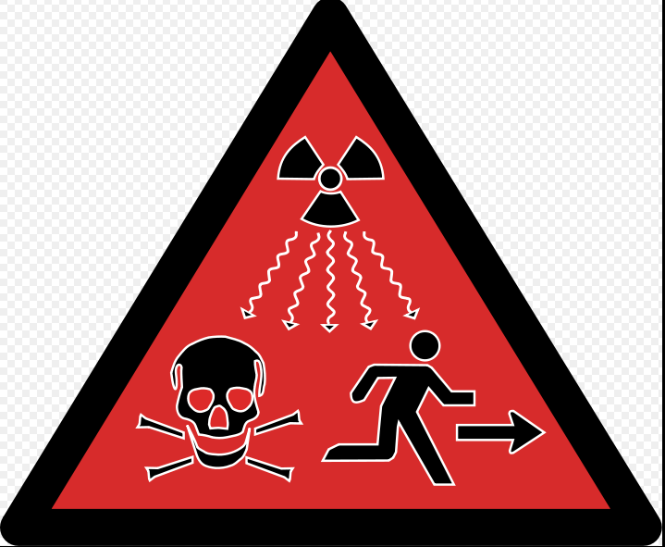
Halt Radioactive Waste Dumping
on New Mexico!

Protect public health by preventing radioactive contamination of land & water

We DO NOT CONSENT to consolidated interim storage of high-level radioactive waste or its transport for this purpose.

Name (please print) | Phone with area code | Email address

Please return signed petitions to Rose Gardner, Alliance for Environmental Strategies, PO Box 514, Eunice, NM NMLady2000@hotmail.com www.NoNuclearWasteAqui.org

